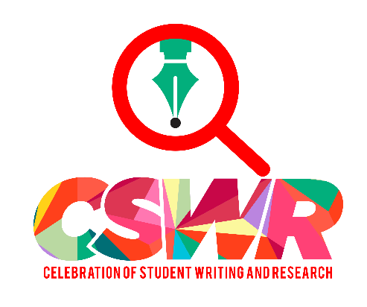

Two Simple Ways to Make the Celebration of Student Writing and Research Work for You!

- Write CSWR into your course syllabus.
When students make real-time presentations to faculty judges and fellow students while competing for prizes, they are getting valuable experience and you are fulfilling an important SAGES objective.

STEP 1: Mark your calendar for Friday, April 19, from noon-2:45 in the Veale Ahletic Center
STEP 2: Schedule an Elevator Pitch Workshop for your class (we’ll come to you but schedule us soon!).
STEP 3: Watch for the registration form for CSWR in your email early March.

2. Check out the Writing Program website (writing.case.edu) and click "Courses and Resources" for a treasure-trove of information about CSWR including:

-A VIDEO of last spring’s event that captures the flavor of CSWR.
-A Power Point that explains the event and its benefits to students with lots of photos.
- Programs from previous events that offer ideas about the range of possible presentation formats.
-A FAQ sheet that will answer questions about all the details of CSWR.

For further information contact:

Barbara Burgess-Van Aken, PhD (bab26)
SAGES Teaching Fellow
Coordinator of Celebration of Student Writing and Research
Department of English
Case Western Reserve University

