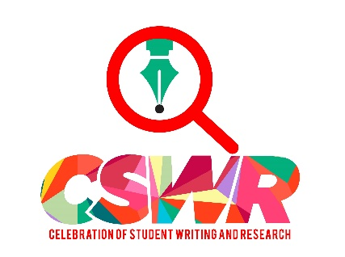

NEWSLETTER (August 2018)
CELEBRATION OF STUDENT WRITING AND RESEARCH

In this issue:
- Best excuses for not participating in CSWR
- New Elevator Pitch Workshop option
- Announcement of Award Winners for April’s Celebration
- Thank you to Judges
TOP 5 EXCUSES FACULTY USE FOR NOT PARTICIPATING IN THE CELEBRATION OF STUDENT WRITING (AND RESPONSES TO THEM)
EXCUSE #1: When I get the notice about registering, I always think it’s a good idea, but I just don’t have the time to squeeze the event into my syllabus.
SOLUTION: Make the Celebration a part of your syllabus from the get-go. Some faculty replace in-class oral presentations with the CSWR. After all, having students talk about their writing and research with faculty and peers is a real-time opportunity for students to engage in academic dialogue with faculty and peers, as well as a perfect ramp-up for presenting capstone projects later in their undergraduate career.

EXCUSE #2: I just can’t think of what to have my class present.
SOLUTION: Put the problem on the class and have them brainstorm about how and what to present. Show them the CSWR Power Point (find it on the Writing Program website) so they can get an idea of what the Celebration is all about and let them have at it. You will be surprised at how creative they can be about coming up with ideas for creating a display to represent what the course has been all about.
EXCUSE #3: I always ask my students if they want to participate, but they’re never interested.
SOLUTION: Faculty tell us that once they made CSWR part of the course syllabus, the students get into it. We’re talking about busy Case students here—they’re not likely to want to take on extra work at the end of the semester. But if the project is part of the syllabus, they will embrace it.
EXCUSE #4: The subject of my course is not conducive to a class presentation.
SOLUTION: You can always just nominate students to present research they have done for your course and forget about a whole-class presentation. You have the option to nominate two individuals or small groups (2-3 students) to participate.
EXCUSE #5: I like the idea of nominating two students to compete for the Individual/Small Group Research Prize, but I have to register mid- semester when it’s too soon to tell which of my students are the best candidates.
SOLUTION: When you register for that particular prize, you don’t have to provide the names of the students; you’re just telling us to hold a place for your nominees. You can provide their names and the titles of their projects just before Thanksgiving break.
Convinced? Then plan Now for Fall’s Celebration which will take place in conjunction with Intersections on Friday, December 7 in the Tinkham Veale Student Center from noon to 2:45. You will receive a registration form mid-semester. Meanwhile, for help with ideas and logistics, contact Barbara Burgess-Van Aken at bab26@case.edu.

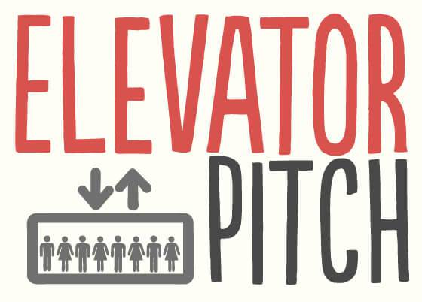
NEW OPTIONS FOR ELEVATOR PITCH WORKSHOPS. SAVE THE DATES FOR FALL OR SCHEDULE A CLASS VISIT!
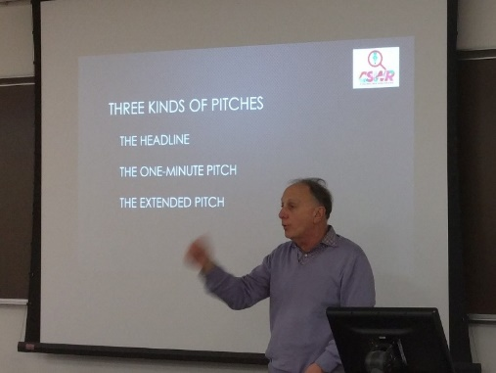
As in the past, Barbara Burgess-Van Aken and Bill Doll will offer Elevator Pitch Workshops in which students learn specific strategies for presenting their research in a succinct, compelling manner to fellow scholars and at-large gatherings such as Intersections and The Celebration of Students Writing and Research. This there are two options for having your students participate. We will offer the session Wednesday, November 28th and Friday, November 30th from 12:45-2:00 (LocationTBA). Send individual students or bring your entire class on either of the two days. This is a very convenient option for those of you teaching First Seminars because you can make the workshop a Fourth Hour event. If you are teaching a University Seminar, you can also schedule Barbara and Bill to come to your class to give a workshop, as long as the time doesn’t conflict with their own classes.

And the Winners Are…
This semester we offered two prizes to students participating in the Celebration. The winners were honored at the Writing Program’s Awards Ceremony at the end of spring semester on May 2. In addition, the Best Class Presentation winners were treated to dinner while the winner of the Best Individual/Small Group Presentation Award received a cash award of $50. For the first time, we also had students vote for their favorite class presentation. In all, we had 17 groups and classes participate with 13 nominees for the Best Individual Research Presentation Award. Many judges commented that the presentations keep getting better and better, so congratulations to all!

Best Class Presentation:
USNA 249: Restoring the Great Lakes FOR THE SECOND CONSECUTIVE SEMESTER!
Instructor: Glenn Odenbrett

Students: Harper Case, Yash Goswami, Katherine Kaminski, Anthony Monczewski, Alexander Mullarkey, John Peralta
Best Individual/Small Group Research Presentation:
FSCC 100: International Student Wellness
Instructor: Mary Assad

Student: Hans Fu

Students' Favorite:
USNA 289E: Medieval Robots
Instructors: Brie Parkin and Greg Lee
Students: Mingda Chen, Sissi Chen, Astra Nicole Driscoll, Gaffney, William Huang, Alan Kao, Elise Kim, Joshua Mehler, Ethan Liaw, Sean Liu, Elizabeth Mahoney, Kimberly Meifert, Monica Oh, Joseph Recchia, Ke Ren, Michael Ritchey, Emily Young

THANK YOU JUDGES!
We are so grateful to the 19 faculty and staff members who generously spent time reviewing presentations and interviewing students at the Spring Celebration. Their interaction with presenters makes the event so meaningful for students and their feedback helps us plan even better future Celebrations. Many thanks to all of you!
FACULTY JUDGES: Gail Arnoff, Barbara Clemenson, Ana Codita, Gusztav Demeter, Leah Davydov, Bill Doll, Narcisz Fejes, Kenny Fountain, Michael Halberstam, Bernie Jim, Kristine Kelly, Terri Mester, Jimmy Newlin, Annie Pecastaing, James Render, Brad Ricca, Arthur Russell, and Martha Schaefer.

