APRIL 2019



The Department of Psychological Sciences Wellness Bulletin

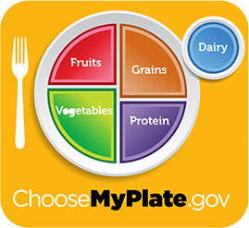

An easy way to get a variety of essential nutrients in your meal is to use the MyPlate as a template:

1. Make half your plate **fruits & vegetables**.

2. Make one quarter of your plate a **whole grain**.

3. Make one quarter of your plate a **lean protein**.

4. Include a **low-fat dairy** on the side.

5. **Healthy fats/oils** can should be used in moderation for flavoring and cooking agents.

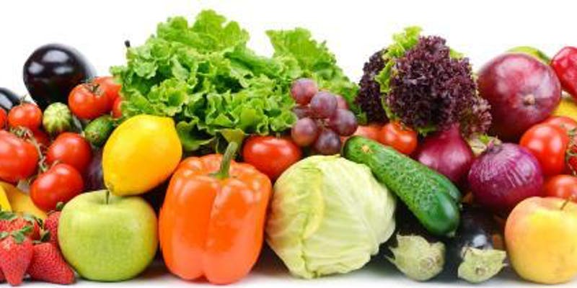

**Date and Time**

Mon, April 22, 2019

4:00 PM – 5:00 PM

**Earth Day! Meatless Meals (Healthy Cooking Demo with samples) at Dave's**

[by University Hospitals Rainbow Center for Women & Children](https://www.eventbrite.com/e/earth-day-meatless-meals-healthy-cooking-demo-with-samples-at-daves-registration-58746988825?aff=ebdssbdestsearch#listing-organizer)

**Location**

Teaching Kitchen inside of Dave's Market & eatery MidTown

1929 East 61st Street

Cleveland, OH 44103

[View Map](https://www.eventbrite.com/e/earth-day-meatless-meals-healthy-cooking-demo-with-samples-at-daves-registration-58746988825?aff=ebdssbdestsearch#map-target)

**Taste samples and take home recipes**

These classes are for everyone! Learn about affordable foods that promote health at any age. They are especially great for people with diabetes, high blood pressure, or high cholesterol.

**Cost is free to attend, but please get a free ticket in advance here on Eventbrite.**

Call Lora Silver, Community Outreach Dietitian, at 216-286-5434 with any questions.

**Free Parking**

Park for free in the store parking lot off of E. 61st Street and Chester.

https://www.eventbrite.com/e/earth-day-meatless-meals-healthy-cooking-demo-with-samples-at-daves-registration-58746988825?aff=ebdssbdestsearch

***As You Like It*** by William Shakespeare  
Directed by Donald Carrier

**April 12, 13, 19, 20 at 7:30 p.m.  
April 14, 21 at 3 p.m.**

In one of Shakespeare’s greatest comedies, the forest, so different from the oppressiveness of court life, is a world where anything is possible. One of the Bard’s greatest heroines undertakes a journey of love, witty wordplay, and music and dancing, as it ultimately lead to forgiveness and reconciliation.

**Box Office**

[BUY TICKETS HERE!](http://theater.case.edu/tickets/)

Eldred Theater Box Office Address, 2070 Adelbert Road.  
Eldred Theater is located on the Case Quad behind the Mills Science Center.

• **Water** - needed for digestion, temperature control, joint health, and nutrient absorption

• **Fiber** - soluble & insolublefood material that helps lower cholesterol and move food through the body

# 5 Amazing Health Benefits of Avocado

Avocado is one of the most delicious and satisfying foods on the planet–and it's also a powerhouse superfood.

Avocados are one of the most rich, delicious, and satisfying foods on the planet. These luscious gems–which are technically fruits, although I categorize them as "good" fat–are packed with anti-aging, disease fighting antioxidants, and nearly 20 different vitamins and minerals.

**They boost satiety**

Eating good fats helps to slow stomach emptying, which keeps you fuller longer and delays the return of hunger. Avocados, which provide about 22 grams of fat each (mostly as [heart healthy monounsaturated fatty acids](https://www.health.com/health/gallery/0,,20477647,00.html), or MUFAs), certainly fit the bill. In one recent study, volunteers rated feelings of satisfaction and appetite after dining on meals with or without avocado. The addition of half of an avocado to meals resulted in a significant boost in self-reported satiety and a [reduced desire to eatthis link opens in a new tab](http://www.nutritionj.com/content/12/1/155/abstract) for up to five hours. This is one of the reasons I often reach for guacamole as my salad dressing.

**They're waist whittlers**

According to a recent survey, Americans are still fat-phobic, probably due to the notion that eating fat makes you fat. But the truth is eating [the right types of fat](https://www.health.com/health/gallery/0,,20477647,00.html) is actually a savvy weight-loss strategy. In addition to upping satiety, plant-based fats like avocado provide antioxidants and fight inflammation, which have both been linked to weight management. That may be why recent research revealed that regular avocado eaters weigh less and [have smaller waiststhis link opens in a new tab](http://www.medicaldaily.com/avocado-health-benefits-eaters-are-thinner-healthier-lower-risk-metabolic-syndrome-244528), even without eating fewer calories.

**They protect your ticker**

The MUFAs in avocados have been shown to slash "bad" LDL cholesterol, and up "good" HDL levels–a double whammy effect that helps to lower the risk of heart disease, the #1 killer of both men and women. A recent UCLA study also uncovered some remarkable heart protective effects of avocado consumption: Compared to eating a burger without avocado, the addition of half of a Hass curbed the production of compounds that contribute to inflammation, [improved blood flowthis link opens in a new tab](http://www.ncbi.nlm.nih.gov/pubmed/23196671), and didn't increase triglycerides (blood fats) beyond the amounts raised by the burger alone. Avocados are also a source of potassium, a nutrient that helps reduce blood pressure by acting as a natural diuretic to sweep excess sodium and fluid out of the body, which relieves pressure on the heart and arteries (bonus: that also means avocado is a natural de-bloater!).

**They're nutrient boosters**

Enjoying avocado at mealtime can help your body absorb more antioxidants from other healthy foods. In one Ohio State study, when men and women ate salads and salsa topped with 2.5 tablespoons of avocado, they [absorbed over 8 times more alpha-carotenethis link opens in a new tab](http://www.ncbi.nlm.nih.gov/pubmed/15735074) and 13 times more beta-carotene–phytonutrients known to fight cancer and heart disease. Another recent study found that pairing avocado with tomato sauce and carrots [boosts absorption of the veggies' vitamin Athis link opens in a new tab](http://www.eurekalert.org/pub_releases/2014-07/fl-nrf071014.php), a key nutrient needed for healthy skin, vision, and immunity.

**They're not just for savory dishes**

I adore guacamole, but one of my favorite things about avocado is that there are so many other ways to enjoy it, including in sweet dishes. I often whip avocado into fruit smoothies, add it to fruit tacos (yes, fruit!), whip it into chocolaty pudding, and substitute it for butter when baking. Just trade each tablespoon of butter in recipes like brownies and cupcakes for half a tablespoon of avocado. This swap slashes calories, upgrades the nutritional quality of your goodies, and still provides the creamy texture that will leave you feeling satisfied. Try it!

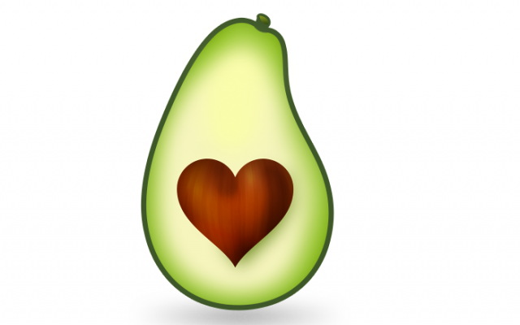

Strawberry AVACADO Taco’s strawberries, whole corn tortillas, edamame, ripe avocado, cilantro and a drizzle of balsamic vinegar.

Avocado Tacos

