Case Western Reserve University

Department of History

Department of Women’s, Gender and Sexuality Studies,

and the Baker Nord Institute for the Humanities

Welcome Dr. Rebecca Davis

Thursday October 9, 2025 at 4:30-6pm in Clark 206

***Fierce Desires: Variation, Conflict, and Pleasure in the***

***History of American Sexuality***

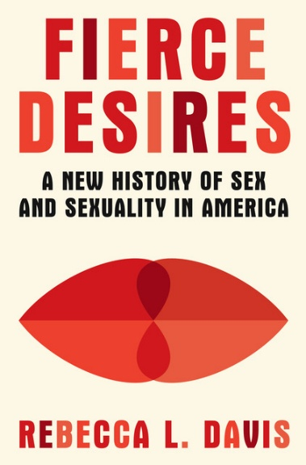In the United States today, we have government decrees that there are only two sexes, debates about “trad wives” and polyamory, and frequent references to the nation’s “puritan” past. But in her latest book—and in this talk—Professor Rebecca L. Davis argues that seventeenth-century Puritans are a weak precedent for how the history of sexuality has unfolded in the United States. Into the 1800s, the United States was far more welcoming of gender nonconformity and same-sex/queer desires than we might presume. Instead, a significant shift occurred in the late nineteenth century, when anti-obscenity and anti-immigration legislation vastly expanded the federal government’s investment in shaping sexual morality. The history that unfolds is far less about prudish puritans than shifting sexual values. Our contemporary conflicts over sex and gender highlight the power of this surprising history.

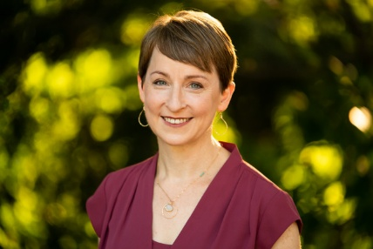Rebecca L. Davis writes and teaches about sexuality, gender, religion, and American history. She is a Professor of History and of Women and Gender Studies at the University of Delaware and the author or editor of four books, the most recent of which is *Fierce Desires: A New History of Sex and Sexuality in America*(W. W. Norton). *Fierce Desires*was supported by a Public Scholar Award from the National Endowment for the Humanities and is a finalist for the Lambda LGBTQ+ Nonfiction Award 2025. Davis has published essays in *Slate*, *Aeon*,the *Los Angeles Times*, and *TIME*, on topics ranging from Muhammad Ali’s conversion to Islam to the legacy of Dr. Ruth. She is a co-host of [*This Is Probably a Really Weird Questio*](http://www.reallyweirdquestion.com/)*n*, a podcast about sexual health and history, and writes the [*Carnal Knowledge*](https://www.houseofspeakeasy.org/) newsletter about the history of sexuality in American life today. Davis lives in Swarthmore, PA.

Case Western Reserve University is committed to academic freedom and promoting diversity of thought.

The views of those who speak on our campus do not necessarily reflect the views of the university administration or any other segment of the university community.

Events are open to all members of the Case Western Reserve University community.